Millbrook Community Update – Issue 3
Planning application submitted
Tom Berger · 07 July 2026
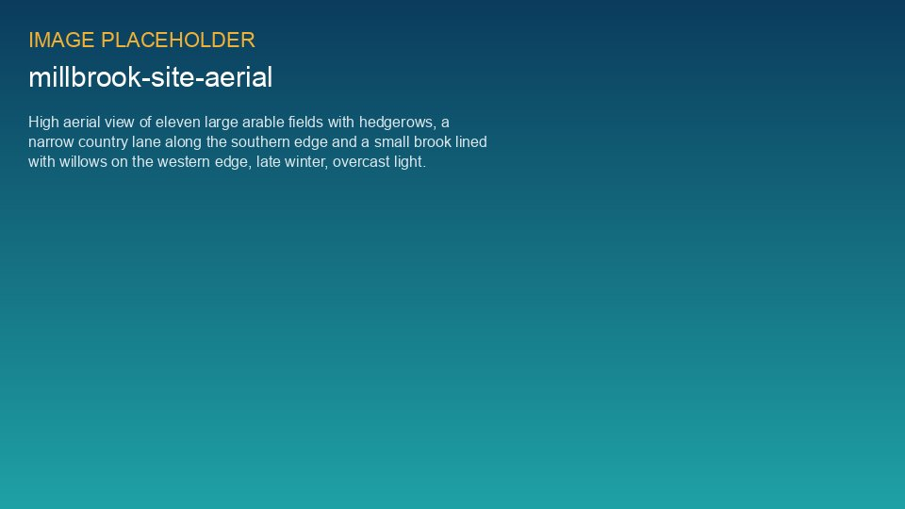
On 18 June 2026 we submitted our planning application to Millbrook District Council. Its reference is MDC/2026/0412 – you can view all documents on the council's planning portal and comment until 6 August.
Thank you to everyone who came to our consultations in March and May – 376 visitors and 299 written responses. They changed the scheme: field 7 removed, a wider footpath corridor, a haul road so lorries avoid Mill Lane, and a community fund of EUR 120,000 a year.
Wildlife: the scheme will deliver a biodiversity net gain of 20 %, with 46 skylark plots and 2.4 km of new hedgerow.

Contact us
Grace Mitchell, Community Liaison Officer – millbrook@weyland-energy.example – drop-in every first Thursday of the month, 16:00–19:00, Millbrook Village Hall.

